H34C Accelerometer Boar v.0107 Assembly Notes:

==============================
GERBER
-----
Filenames are “H34MOTE15” with the following extensions:

.DRL DRILL FILE

.OTL BOARD OUTLINE
.TOP TOP METAL
.BOT BOTTOM METAL

.SMB SOLDER MASK BOTTOM
.SMT SOLDER MASK TOP
.SPB SOLDER PASTE BOTTOM
.SPT SOLDER PASTE TOP
.SST SILK SCREEN TOP
.SSB SILK SCREEN BOTTOM

IMPORTANT NOTE(S):
-----

MOTE1 and J4 are identical footprints. Exercise caution to ensure that each component is installed on the correct side of the board. J4 (DF9-51P) is on the TOP, MOTE1 (DF9-51S) is on the BOTTOM by silk marking “MOTE”. THESE ARE DIFFERENT MFR PART NUMBERS.

DO NOT POPULATE THESE PARTS:
-----
Item # Part Reference
(see BOM v.0107)
5 J11

There is a 8 pin header in the upper-right corner of the board that does not have a reference designator and is not populated.

TOP LAYER:

HEADERS
-----
Item # Part Reference
4 J6, J7, J8 : Place the switch so that it faces the outside of the board.
6 J12

BOARD-TO-BOARD CONNECTOR
-----
Item # Part Reference
3 J4 : Align the connector with the holes. The side with more pads faces the edge of the board.

ACCELEROMETER SENSOR
-----
Item # Part Reference
1 ACCEL
: Pin1 is indicated on the actual part with a dot as shown; Pin1 is indicated on the PCB silk with a “1” and a long line. Please align accordingly.
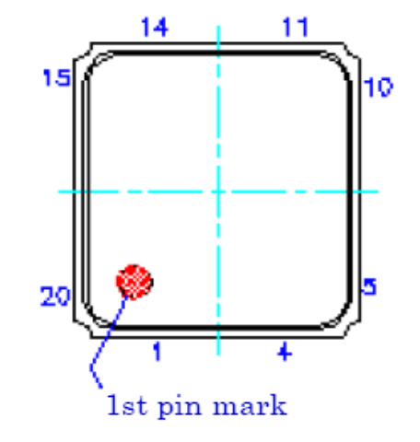
BOTTOM LAYER:

BOARD-TO-BOARD CONNECTOR
-----
Item # Part Reference
8 MOTE1 : Align the connector with the holes. The side with more pads faces the edge of the board.

***************************************************************************
CALL US IF YOU HAVE QUESTIONS, ANY TIME DAY OR NIGHT (INCLUDING WEEKENDS, HOLIDAYS, ETC):

UCLA NES Laboratory (310-825-7707, 310-206-5698)
Jonathan Friedman, jf@ee.ucla.edu, 404-259-8168
***************************************************************************

